**LAB 07**

Q1) Use loop instruction to display decimal value till 15 and store this value in another array of size 15 and then display the stored array results in data register.

**Program:**

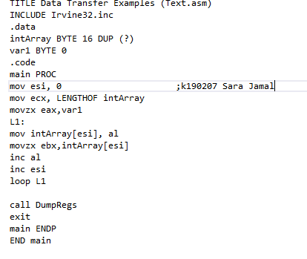

**Output:**

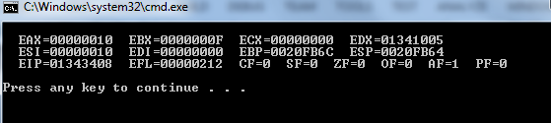

**(Array displayed by EBX register):**

































Q2) Using a loop move incremental values in eax.

**Program:**

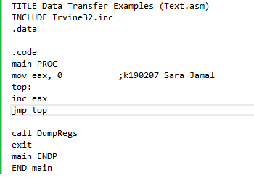

**Ouput:** (eax keeps increasing)













…..and so on

Q4) Write a program to calculate the factorial of the program.

**Program:**

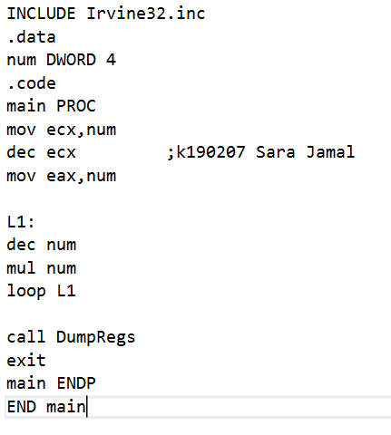

**Output:** (factorial stored in eax register)

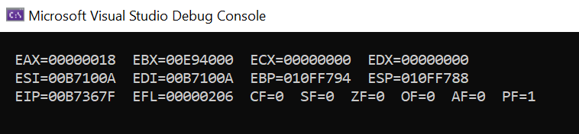

Q5) Use loop instruction to display 100 number in decimal and display them in register.

**Program:**

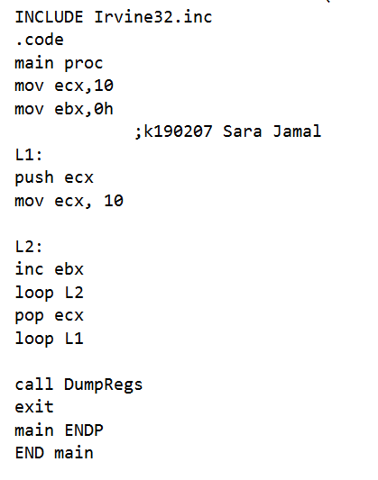

**Output: (ebx keeps increasing till dec 100)**

